Sorting by Emotions: the cataloguing system of the Garden Library

The indexing and cataloguing system of the Garden Library is a dynamic classification system based on reader input. On the inside back cover of each book is a sticker that asks, “How would you describe the book?” and offers seven emotional responses the book may evoke: amusing, boring, bizarre, depressing, exciting, inspiring, sentimental.
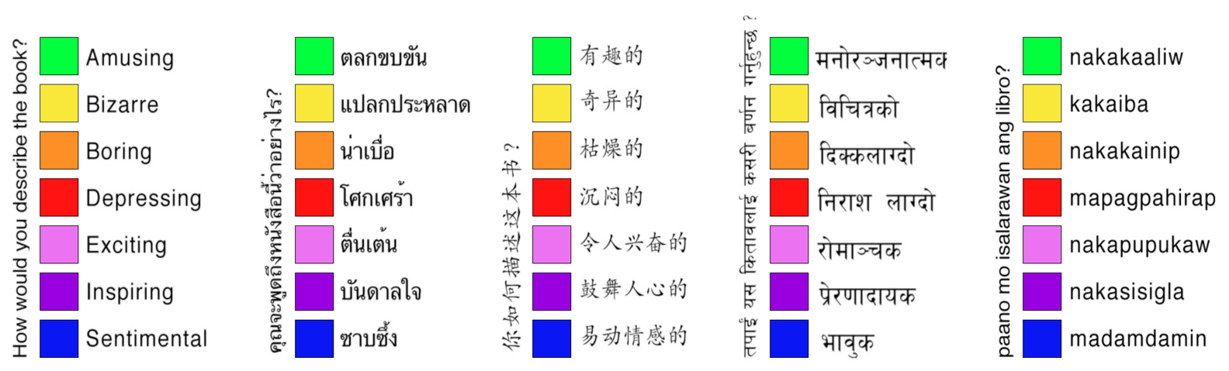Emotional categories stickers (English, Nepalese, Mandarin, Thai, Tagalog)

When returning a book, the reader is asked to choose the fitting emotional descriptor, and the color-coded judgment is added to the past history of responses on the spine of the book. The book is then placed on the shelves according to its latest emotional classification. In other words, the placement of the book is not decided by popular vote, but by the last reader, using a dynamic system that everyone can impact and in which every participant’s input counts.

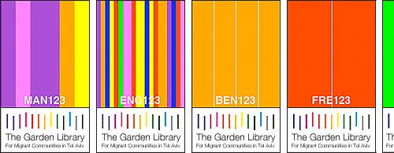
History stickers (Mandarin, English, Bengali, French)

The cataloguing system continuously restructures the layout of the book collection, creating at any given point in time a transient “wandering map” that reflects the readers’ opinions and preferences. The system offers a dynamic, interactive structure that mirrors the transience and mobility of its users, while at the same time affording these otherwise disenfranchised individuals agency over the system itself.

The library’s database visualization project complements the physical library by introducing a broader public to the tastes and preferences of the individuals who make up the library readership. The application provides users with the means to navigate the cumulative database, and to view the nomadic patterns created as individual books wander from one emotional category to another.

The interactive visualization offers a portal into learning about the foreign worker community as a community of individuals whose various paths through the books on the shelves recall the various paths they traveled that led them to the Middle East, to Tel Aviv, and to the library itself.

